Task 6.4

Isaac Pittolo – 7695438  
Hoang Linh Bui – 100017631  
Adam Bubonya – 9986677

# Task Board Updates

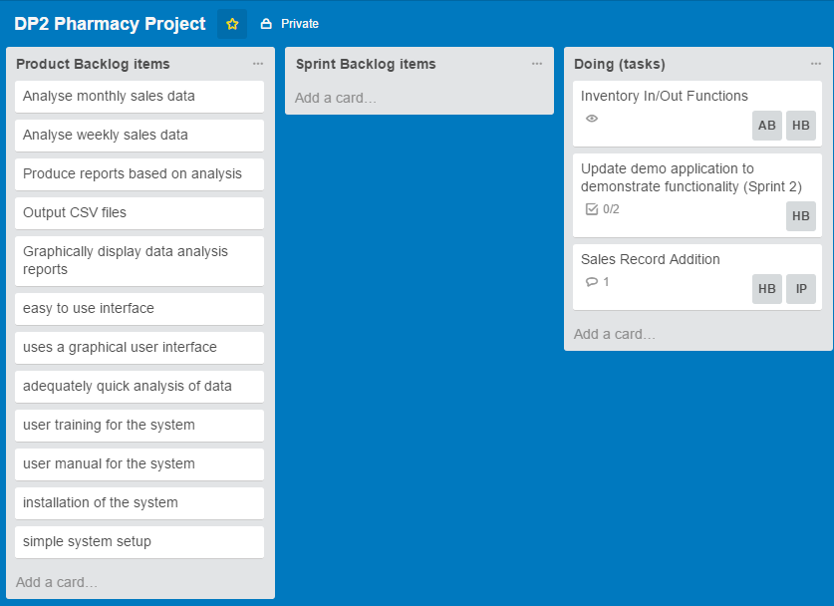

The biggest change to the task board is the demonstration functionality. We felt that the project lacked a big of depth, it was very difficult to actually demonstrate what we have actually done. Therefore, a new task was added to add demonstration functionality.

# Burn Down Chart

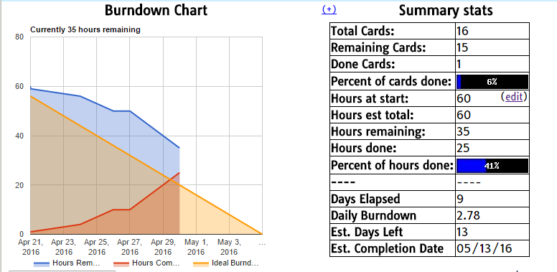

*Note: This screenshot was taken a little bit into the project, but still accurately represents the information desired.*

# Project Repository

